Quarterly Progress Report

|  |  |
| --- | --- |
| Project Title:  FY15 WBS – Agreement: | Hydrothermal Processing of Biomass – PNNL  2.2.2.301 – 26720 |
| Reporting Period: | 1 October 2015 – 31 December 2015 |
| Date of Report: | 15 January 2016 |
| Milestone: | Brief BETO on outcomes of Wet Waste TEA and strategy for focused testing to address areas of highest technical risk and economic uncertainty and validate SOT assumptions. |
| Written by: | Richard Hallen  richard.hallen@pnnl.gov  509.375.6919 |
| Participating Researchers: | LJ Snowden-Swan, AJ Schmidt, DC Elliott, JM Billing, DM Santosa |
| Key Words: | Hydrothermal liquefaction, wet waste, techno-economic analysis |
| Reviewed By: | Corinne Drennan |

**Summary**

The FY16 Q1 milestone was, “Brief BETO on outcomes of Wet Waste TEA and strategy for focused testing to address areas of highest technical risk and economic uncertainty and validate SOT assumptions” was completed and attached as Appendix A. Based upon results of the wet waste assessment conducted in FY15 Q4, waste water sludge was selected for the TEA. A process model was developed and the techno-economic assessment completed for fuel produced from hydrothermal liquefaction and upgrading of sludge waste from a municipal wastewater treatment plant (WWTP). The TEA identified combined process improvements which could reduce the minimum fuel selling price to $2.92/gge. Details of the assessment are discussed in detail in Appendix A.

**Technical Achievement:** This milestone represents the first detailed assessment of wet waste feedstock for HTL and potential application to municipal wastewater treatment sludges. This TEA has identified key areas for process improvements for meeting the $3.00/gge target.

**Relation to Program Goals:** The combined feedstock and TEA assessments concluded that 55 individual WWTP within CONUS produced enough wet waste feedstock for an HTL commercial plant to meet the DOE $3/GGE target. The total renewable fuel impact from these 55 plants was estimated to be 371MG/yr.

**Comparison to State of the Art:** The testing conducted at PNNL to support this milestone examined wet wastes as feedstocks for biocrude production. In general, the wet wastes are not viable feedstock for pyrolysis or gasification because of the high water content. However, hydrothermal liquefaction is conducted with water in the condensed phase and utilizes chemistries in liquid water solvent to produce a phase separable biocrude. The results of this work demonstrated the use of low cost, waste feedstock for production of biocrude. The biocrude can be easily upgraded to a hydrocarbon mixture with a high yield of distillate range product. The upgraded biocrude from the WWTP sludge contained high concentrations of parrafins in the diesel boiling range which provide higher cetane fuels compared to upgraded biocrude from conventional lignocellulosic feedstocks such as wood, corn stover, switch grass, and wheat straw.

**Lessons Learned:** Wet waste feedstocks from WWTP are currently available at single sites in quantities large enough to support a commercial scale HTL plant. In addition, the wastewater sludges contain significant fats, oils, and greases which result in a higher cetane distillate fuel relative to conventional lignocellulosic feedstocks. The TEA analysis identified that increasing the liquid hourly space velocity to the algae SOT value (4) will result in target fuel production costs of <$3/GGE.

**Plans for Next Quarter:** PNNL has been working with various partners and other DOE labs to acquire feedstocks to meet the Q2 milestone, “Demonstrate 100 hours of time on stream for plug-flow HTL. Produce ~ 4L of HTL biocrude in a continuous bench scale reactor to demonstrate HTL performance and to provide a feedstock for upgrading.” Operating HTL in the plug flow mode requires operating at high linear line velocities which translates to high overall feed rates. The feed requirement for the 100 hours of time on stream is estimated to be over 100 kg of feedstock on a dry basis. INL was able to provide 13 kg of formatted wood feedstock which only allow approximately 12 hours of time on stream. PNNL will continue to explore options for additional feedstocks as the only currently available feedstock in quantities approaching 100 kg is for algae.

**Background (including other milestones)**

**Project Objectives:** The objectives of this project work is to advance the state of hydrothermal liquefaction technology (HTL), improve overall process performance and economics, and determine the value and best pathway to market for the product. The HTL technology has unique and compelling attributes for the production of biocrude from woody, agricultural, and waste feedstocks. This effort will advance the technical readiness/modality of HTL through leveraging existing capabilities, programs, key relationships and the recent HTL developments under national consortiums (NABC and NAABB) and Work for Other (WFO) agreements. We will focus the R&D efforts on the highest priority challenges identified in internal and independent TEAs and design evaluations.

PNNL has developed processes for preparing biomass slurries (10 to 20wt% solids) for high pressure pumping and conducting heating/reaction in a simple tubular reactor (plug flow). Separation processes have been developed and demonstrated for solids (primarily ash), gas, and separation of the biocrude from the resulting aqueous product stream by simple gravity settling. The NABC consortium contributed to the substantial progress on the HTL technology in areas such as plant-scale reactor design, pump ability, materials of construction specification, and process separations (solids removal, oil/water separations, organic concentration). The upgrading of the biocrude was also demonstrated and evaluations conducted for insertion into existing petroleum refineries.

Technology development activities from recently funded projects has progressed HTL capabilities at PNNL to a fully plug flow reactor system for use in liquefaction that can be operated with online pressure letdown and biocrude product separation. However, some feedstock specific issues still require a stirred-tank preheater and the equipment remains available in the bench-scale test stand. This HTL system provides the capabilities necessary to evaluate a broader range of feedstock including wet agricultural and industrial wastes.

**Project Overview:** Hydrothermal liquefaction is very carbon efficient with regards to the percent carbon converted to biocrude, with yields around 50% for woody and agricultural residual feedstocks. The major loss of carbon is to the aqueous phase, which contains many small water soluble (highly oxygenated) organic compounds. HTL biocrude has relatively low oxygen content (10 to 20%), but can exhibit undesirable physiochemical properties for certain feedstocks (e.g. viscosities in excess of 1000 cSt for wood waste products). Improvements to the chemical and physical quality of HTL bio-oil and reduction of the fraction of organics reporting to the aqueous stream are essential to the advancement and maturation of the HTL pathway.

This project will continue the development of the HTL technology for fuel production and expand the range of feedstock to include wet wastes. Expected outcomes upon successful completion of the project include:

• Expand bench-scale HTL testing with a broader range of biomass and waste feedstocks.

• Determine biocrude yields and quality as a function of feedstock composition.

• Validate processing improvements and provide compelling process data and detailed chemical characterization to establish the state of the technology for HTL.

• Demonstrate a step change improvement in HTL processing for fuel production.

• Confirm the value of the of upgraded HTL biocrude and distillate products through detailed characterization and finished fuel property testing.

• Progress towards the BETO $3/GGE case by reducing technical uncertainties in scalable HTL reactor design.

• In collaboration with industrial partners, demonstrate hydrothermal process for converting wet biomass wastes to biocrude for production of liquid hydrocarbon fuels.

• Complete TEA for the integrated process of wet waste biomass to fuels and goal case to meet BETO’s goal of $3/gge.

PNNL will acquire a boarder range of biomass feedstocks, including feedstock cost estimates and characterization data, and assess/develop approaches for conditioning the feedstock for HTL processing. Bench-scale, continuous feed experiments will be conducted to baseline HTL performance with various feedstocks and while examining HTL process improvements through modification of the engineering and/or process chemistry. The impact of biocrude yield and quality will be assessed as a function of feedstock. Extended HTL runs will then be conducted with the most promising feedstock to generate large enough samples of biocrude for upgrading.

Biocrude samples will be upgraded in continuous-flow lab-scale and bench-scale hydrotreaters at PNNL. PNNL will evaluate hydrotreating performance with the baseline CoMoS catalyst as a function of time on stream (TOS) and extend catalyst lifetime testing up to at least 200 hours of TOS. The impact on upgrading with improved, higher activity hydrotreating catalyst will be examined. The upgraded biocrude samples will be analyzed by advanced characterization techniques and further refined to create distillate fractions for fuel characterization.

Detailed characterization of biocrude samples from a wide range of feedstock will be performed, including use of FT-ICR MS at New Mexico State University. The assessment of biocrude quality includes the relative ease to upgrade, hydrogen requirement, and by the quality of the hydrocarbon products. For any bio-derived fuel to obtain widespread use it must qualify as “fit-for-purpose” as a drop-in replacement (or blending component) for compression ignition engines, spark ignition engines, or gas turbines. Upgraded HTL biocrude from wood and forest waste have a high yield to mid-distillate fuel with a high aromatic/high naphthenic content. To assess the value of upgraded HTL distillate products, physical and chemical properties will be assessed at the PNNL Fuel Testing Laboratory.

The experimental works will be summarized in data packages and provided to the TEA-LCA team for assessment. Existing models will be modified based up analytical and engineering results for a range of feedstocks. A techno-economic assessment of hydrothermal processing and the effect of waste material avoided cost and its impact on the process costs will be completed. The TEA/LCA team will assess the techno-economic feasibility and progress, evaluate life-cycle impacts, and improve sustainability for hydrothermal processing of biomass wastes. The process models will be used to conduct sensitivity analyses and identify the most significant areas of the overall process for economic improvement to guide future R&D activities.

**Table 1.** Milestone and Deliverables Table.

|  |  |  |  |  |
| --- | --- | --- | --- | --- |
| **ID Number** | **Quarter** | **Due Date** | **Type** | **Narrative** |
| M1 | Q1 | 12/31/2015 | Regular | Brief BETO on outcomes of Wet Waste TEA and strategy for focused testing to address areas of highest technical risk and economic uncertainty and validate SOT assumptions. |
| M2 | Q2 | 3/31/2016 | Regular | Demonstrate 100 hours of time on stream for plug-flow HTL. Produce ~4L of HTL biocrude in a continuous bench scale reactor to demonstrate HTL performance and to provide a feedstock for upgrading. |
| M3 | Q3 | 6/30/2016 | Regular | Acquire 3 feedstocks from industrial partners identified in resource assessment and complete bench-scale HTL tests sufficient for product (biocrude) analysis (500 ml biocrude) as well as production of aqueous byproduct (1 gallon) sufficient for testing. Quantify product yields and qualities (including biocrude viscosity, density, and CHNOS). |
| M4 | Q4 | 9/30/2016 | Regular | Upgrade and refine 4L of HTL biocrude to assess upgrading yields and generate samples for fuel testing. Brief BETO on combustion properties for fuels (or fuel blends) from upgraded HTL biocrude obtained in plug-flow HTL configuration. |
| GN | Q2 | 3/31/2016 | G/NG | CAT HTL to Meet 2015 Cost Target for pyrolysis and path forward for HTL wet waste industrial demonstration |

**Experimental Methods**

PNNL has assembled continuous flow reactors for both HTL and upgrading of HTL biocrude to hydrocarbons. The reactors are large enough to allow good mass balance, yield, and conversion calculations while utilizing relatively small feedstock and biocrude sample sizes. The resulting upgraded hydrocarbon samples are large enough to allow fractionation and fuel property testing. The results of the testing at PNNL are at a large enough scale to support process model development, techno-economic analysis, and assessment of the environmental impact as renewable fuels.

**Results and Discussion**

**WERF data packages:** Complete mass balance calculations, all analytical data, and scans of the run binders were prepared and sent to Leidos for validation and reporting of the four WERF HTL runs conducted over the summer. Support and clarification was provided to Leidos on an ongoing basis. Leidos completed the draft validation report on December 29 and provided a copy to PNNL for review. PNNL will complete the report review in Q2 before the WERF scheduled review meeting at PNNL in February.

The results from WERF testing were presented at tcbiomass2015 in Chicago on November 4, 2015. The work was well-received and a number of inquiries/discussions were initiated about future processing of wet wastes at HTL.**TEA for Wet Wastes:** The base case scenario for the wet waste techno-economic analysis consists of 25 HTL plants, each processing 100 dry ton/day of sludge waste, feeding into a centralized biocrude upgrading facility that produces 5,047 barrel per standard day of final fuel. This scale was chosen based upon initial wastewater treatment plant data gathered by the PNNL resource assessment team and a rough estimate of what the potential sludge availability might be within a 100-mile radius. It is assumed that sludge is available at no cost and biocrude is shipped for $0.10/gge. The base case assumptions result in a minimum biocrude selling price of $4.09/gge and a minimum final upgraded fuel selling price of $5.15/gge.

Several areas of process improvement and refinements to the analysis have the potential to favorably impact economics relative to the base case; Optimization of HTL biocrude yield, Optimization of HTL sludge feed solids content, Optimization of upgraded biocrude yield, Inclusion of cost savings associated with avoided sludge disposal (sludge credit), and Combined large and small HTL scales (e.g., in metropolitan and outlying areas). With these combined improvements, the minimum selling price of biocrude and final fuel can potentially reduce to $2.37/gge and $2.92/gge, respectively. Further improvements may be possible through recovery of higher value components from the HTL aqueous phase, as being investigated under separate PNNL projects.

**Wet Waste-05 HTL Run, IPA Brewer’s Grains:** Ten gallons of brewer’s spent grains were collected from Ice Harbor Brewery in Kennewick, WA. As part of the brewing process the grains were cracked, malted, and extracted with water at 154°F for approximately 1 hour. The brew master estimated that 75% of the fermentable sugars had been extracted. The extracted grains required feed formatting process for pumping to the bench-scale HTL system. The wet feed was formatted using a wet milling process which was carried out batch-wise (1-2 L/batch) to create a pumpable slurry. The feed slurry was 13.6 wt% solids and 0.5 wt% sodium carbonate added as a buffering agent as a precaution since this feed has not been run and had an unknown nitrogen content (protein content). The feed was relatively low ash at ~6 wt%.

The HTL run was conducted in bench-scale continuous feed HTL system (CRS-2) in the pure plug flow configuration at baseline conditions (350°C, 3000 psig). The feed rate was 4 L/h (initially 2 L/h) for a nominal LHSV=8 h-1. This is a feed rate 4 times higher than the baseline for lignocellulosic feedstocks and 2 times higher than the SOT for algae HTL. The feed was successfully processed into gravity-separable biocrude over a period of approximately 9 hours (>30L of slurry converted). The oil density was 1.05 g/cc and the viscosity was similar to a wood-based biocrude at 8,100 cSt at 40°C. The oil samples were relatively high in moisture with 14 and 25 wt% moisture for the steady state and rapid let-down oils, respectively. Over 600 mL of biocrude was collected for upgrading in Q2. The aqueous product was collected and characterized. The COD of the aqueous phase ranged from 55,000-60,000 mg O/L, a typical value for a lignocellulosic feedstock.

**Hydrotreating of Wet Waste HTL biocrudes:** Three hydrotreater runs were completed in Q1 with HTL biocrude samples. The first run was conducted with two biocrude samples derived from the HTL of the WWTP sludges. The second hydrotreater run was conducted with biocrude from HTL of grape pomace, a wet waste from regional wineries. The third hydrotreater run was conducted with slurry comprised of oleaginous yeast that was grown on hydrolyzed corn stover feedstock (including the lignin fraction. All HT runs were successful in generating a hydrocarbon product with good yield of distillate range fuels as demonstrated by simulated distillation. Figure 1 compares the results from the WWTP primary sludge and tetraselmis marine algae. The upgraded products from both feedstocks were very similar with respect to yield of distillate fuel, ~75%. The simulated distillate curve for petroleum derived diesel is included for comparison to the upgraded biocrude samples.

The normal paraffin contribution to the diesel distillate range was surprising high for the upgraded WWTP sludge biocrude. Figure 2 shows a comparison of the GC-FID chromatograms for upgraded WWTP primary sludge and tetraselmis derived biocrudes. The yield of n-alkanes is similar with the upgraded WWTP sludge having higher n-C18 content and a wider overall n-alkane distribution. The high lipid content of the WWTP primary sludge resulted in a distillate high in n-alkanes in the C-15 to C-18 range. A chromatogram for a QC diesel is included which shows the wide range of n-alkanes in petroleum derived fuel.

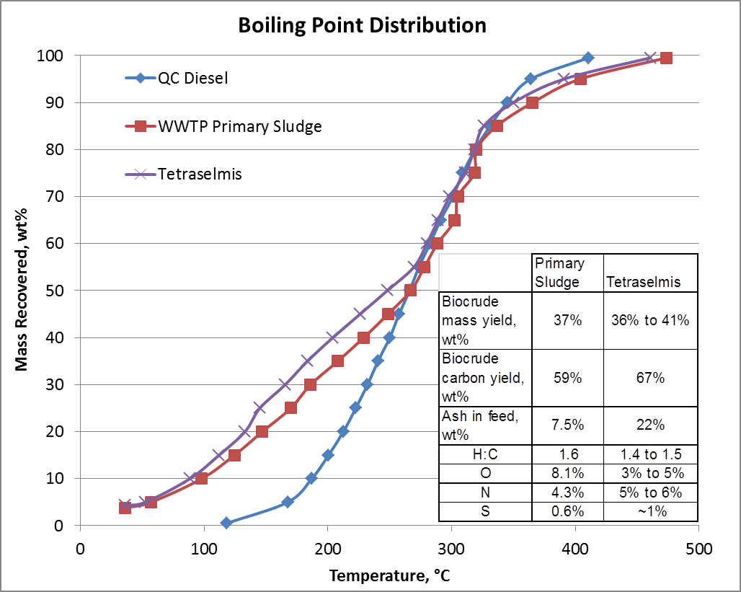

**Figure 1.** A comparison of HTL and upgraded products from WWTP primary sludge and tetraselmis marine algae. The upgraded biocrude from both feedstocks has high yields of distillate range hydrocarbons. The simulated distillation data for petroleum derived diesel is included for comparison.

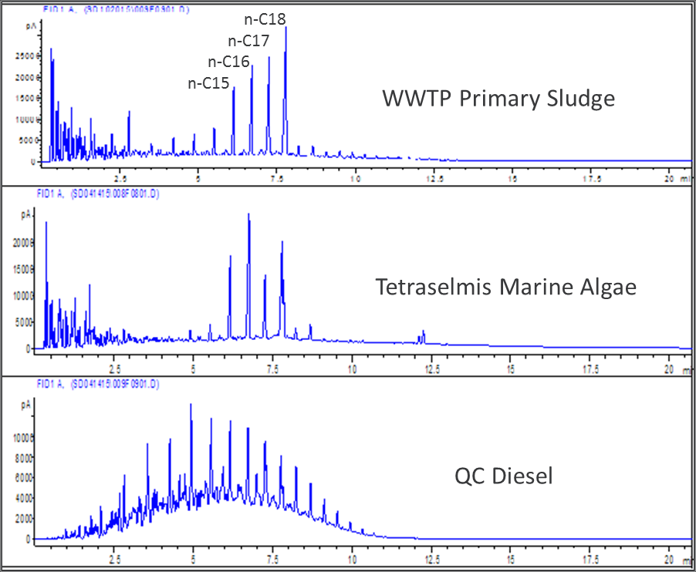

**Figure 2.** A comparison of the GC-FID chromatograms for upgraded WWTP primary sludge and tetraselmis derived biocrudes. For reference, the chromatogram for petroleum diesel is included.

**Conclusions and Future Work**

**Conclusions:** Wet wastes provide an ideal feedstock for HTL processing to produce a biocrude product. The biocrude can be easily upgraded to a hydrocarbon product with high yield to the distillate range. The upgraded product from WWTP sludges and grape pomace waste had surprising high paraffin yield in the diesel distillate range which results in higher cetane value fuels than the usual lignocellulosic feedstocks.

**Future work:** PNNL will continue examining new waste feedstocks for HTL processing. With the goal of longer time on stream runs and production of larger quantities of fuel for property and engine testing, large quantities of feedstock will be required. PNNL will continue to work with industry and other national laboratories to acquire feedstocks for future testing.

**Publications and Presentations**

A manuscript was prepared and submitted to ACS Sustainable Chemistry & Engineering for publication, “Hydrothermal Processing of Grape Pomace Feedstocks in Continuous-Flow Reactors,” Douglas C. Elliott, Andrew J. Schmidt, Todd R. Hart, and Justin M. Billing

A paper summarizing the HTL of the WWTP sludges was presented at tcbiomass2015, “Continuous Flow Hydrothermal Liquefaction of Biomass Feedstock,” **Justin Billing**, Andy Schmidt, Todd Hart, Gary Maupin, Karl Albrecht, Huamin Wang, Dan Anderson, Rich Hallen, and Doug Elliott. November 4, 2015. PNNL-SA-109490.

**APPENDIX A**

***Milestone***

“Brief BETO on outcomes of Wet Waste TEA and strategy for focused testing to address areas of highest technical risk and economic uncertainty and validate SOT assumptions.”

***Milestone Accomplishment***

An initial process model and techno-economic assessment (TEA) was completed for the hydrothermal liquefaction (HTL) of a wet waste feedstock. Specifically, the process model and TEA for fuel production were developed from hydrothermal liquefaction and upgrading data from the processing of sludge waste from a municipal wastewater treatment plant (WWTP). The model is adapted from previous work by Jones *et al* (2014) for the HTL and upgrading of algal feedstock. The HTL experimental plan was developed in collaboration with the Water Environmental Research Foundation (WERF) The data used for the TEA was generated in FY2015 utilizing the bench-scale HTL system of sludge waste streams received from the Annacis Island WWTP in Vancouver, B.C.

***Future Work***

This TEA is based on limited HTL testing of wastewater sludge from a single feedstock source and utilizing conservative HTL processing conditions. Refinements to the model should also be made in the future, including a more detailed cross-check of modeled biocrude components with the experimental GCMS data. Environmental sustainability metrics analysis is needed to understand the broader impact of this technology pathway. This appendix serves as the initial briefing to BETO on the results of this work. WERF has conducted an independent validation of the experimental work and has scheduled a review meeting at PNNL in February. Upon completion of the review, a final report will be issued by WERF including recommendations for future work.

## Summary

The base case scenario for the analysis consists of 25 HTL plants, each processing 100 dry ton/day of sludge waste, feeding into a centralized biocrude upgrading facility that produces 5,047 barrel per standard day of final fuel. This scale was chosen based upon initial wastewater treatment plant data gathered by the PNNL resource assessment team and a rough estimate of what the potential sludge availability might be within a 100-mile radius. It is assumed that sludge is available at no cost and biocrude is shipped for $0.10/gge. The base case assumptions result in a minimum biocrude selling price of $4.09/gge and a minimum final upgraded fuel selling price of $5.15/gge.

Several areas of process improvement and refinements to the analysis have the potential to favorably impact economics relative to the base case:

* Optimization of HTL biocrude yield
* Optimization of HTL sludge feed solids content
* Optimization of upgraded biocrude yield
* Inclusion of cost savings associated with avoided sludge disposal (sludge credit)
* Combined large and small HTL scales (e.g., in metropolitan and outlying areas)

As shown in Figures S.1 and S.2, combined improvements in these areas can potentially reduce the minimum selling price of biocrude and final fuel to $2.37/gge and $2.92/gge, respectively. Further improvements may be possible through recovery of higher value components from the HTL aqueous phase, as being investigated under separate PNNL projects.

**Figure S.1** Overall potential reduction in base case biocrude price through applied sludge credit, technology advancements, and combined scale scenario.

**Figure S.2** Overall potential reduction in final fuel MFSP through applied sludge credit, technology advancements, and combined HTL scale scenario.

## Hydrothermal Liquefaction and Upgrading of Wastewater Treatment Plant Sludge: A Preliminary Techno-Economic Analysis

## Introduction

A FY15 study at PNNL estimated that nearly 7 million tons of sludge are produced annually at wastewater treatment plants (WWTP) around the nation. Wastewater treatment produces sludge as a result of primary and secondary treatment processes. The most common methods that WWTPs currently use to manage their sludge include anaerobic digestion (AD) to produce Class A or B biosolids, landfill disposal, and incineration. The AD process produces biogas, which is used in the process and onsite for heat, and biosolids, which are generally land applied for a fee. Whatever the option, sludge management is costly and some options, such as landfilling, provide no added benefit. Land application of biosolids (after AD) provides added fertilizer benefit, but in some areas, faces the challenge of public concern over health risks (SCAP 2013).

Production of fuel via hydrothermal liquefaction (HTL) could provide an economically favorable alternative to AD and other current sludge management practices. The purpose of this study is to provide preliminary economics for this strategy, including sensitivity analyses around key assumptions for the conversion plant.

## Techno-Economic Analysis Approach

The approach to developing conversion process techno-economics is similar to that employed in previous conceptual design reports produced for BETO [Jones *et al.* 2009, Dutta *et al.* 2011, Humbird *et al.* 2011, *Jones et al.* 2014]. Process flow diagrams and models are based on experimental results from completed and ongoing research, as well as information from commercial vendors for mature and similar technologies. To assure consistency across all biomass conversion pathways, BETO developed a set of economic assumptions that are used for all technoeconomic analyses (see Appendix) and are documented in BETO’s Multi-Year Program Plan (DOE 2015). An important aspect of these assumptions is that they reflect an “nth plant” design. The nth plant design assumes that several plants have already been built and operated and therefore does not account for additional first-of-a-kind plant costs. All costs presented are given in 2014 dollars.

## Process Design and Assumptions

## Process Overview

The design and cost basis is based largely on work done previously for algae HTL and biocrude upgrading (Jones *et al* 2014). A simplified block diagram of the HTL and biocrude upgrading process configuration is shown in Figure 1. Results from a PNNL FY15 resource assessment indicate that it is likely that application of this technology for municipal WWTP waste would involve multiple HTL plants feeding into a centralized upgrading facility. Based on these results, a HTL facility scale of 100 dry ton/day primary sludge is chosen as the base case for the analysis. For the centralized upgrading facility, a capacity of 5,047 BPSD of diesel and gasoline is chosen as the base case (receiving biocrude from 25 HTL plants). All capital costs for the HTL plant and the upgrading facility are scaled on values used in the algae HTL design case (Jones *et al.* 2014).

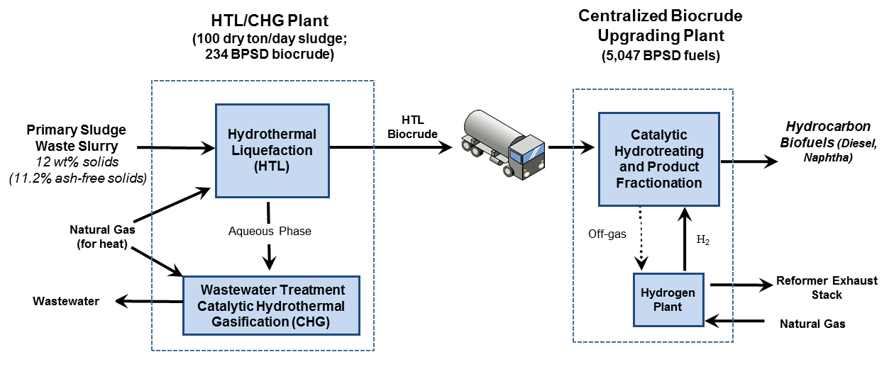

Figure 1. Simplified block diagram for the HTL/CHG plant and centralized biocrude upgrading plant receiving biocrude from multiple regional HTL facilities.

## Feedstock and Plant Scale

In FY15, PNNL conducted experimental testing of HTL and biocrude upgrading of WWTP plant sludge wastes provided by the MetroVancouver operated Annacis Island WWTP in Vancouver, B.C. The facility produces primary and secondary sludge solids that are further processed in thermophilic anaerobic digesters, resulting in Class A biosolids. Class A biosolids is the designation for sewage solids that meet U.S. EPA guidelines for land application with no restrictions (EPA 2015). The Annacis Island WWTP’s anaerobic digestion facility is shown in Figure 2.

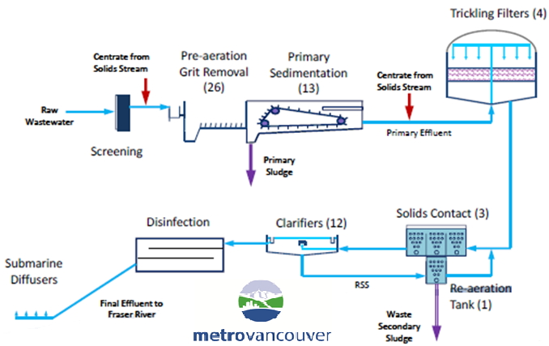

Figure 2. Simplified flow diagram of Annacis Island WWTP showing primary and secondary sludge generation that is then treated with thermophilic anaerobic digestion.

Experimental data for primary sludge was used in the process modeling for this analysis. Based on PNNL’s FY15 resource assessment, a scale of 100 dry ton/day was chosen as the base case. The sludge is assumed to be available at no cost and sensitivity analysis is conducted to investigate the effect of scale and sludge credit on the minimum fuel selling price (MFSP) of biocrude. The upgrading plant is assumed to receive biocrude from 25 HTL facilities and to produce 1,432 BPSD of naphtha and 3,615 BPSD of diesel. The choice of this scale is roughly based upon the number and capacity of existing WWTPs that produce around 100 ton/day and what the sludge availability might be within a reasonable transportation radius. This plant size is also in the range of other BETO design cases (Jones *et al.* 2014, Jones *et al.* 2013). For comparison, the average scale for gasoline and diesel production at U.S. refineries is about 50,000 BPSD (EIA 2015). Sensitivity analysis was conducted for both the HTL and upgrading plant scales.

Table 1 lists the primary sludge composition data used in the AspenPlus model. The original sample received from the WWTP required dilution with water to 88% moisture content (12% solids) in order to facilitate pumping. It is assumed that the sludge would be dewatered at the WWTP to the level needed for the HTL process. Costs for dewatering were not included in the analysis, and should be considered in future refinements of the model.

**Table 1** Primary sludge biomass elemental composition and ash content.

|  |  |  |
| --- | --- | --- |
| **Primary Sludge Characteristics** | **Experimental data used in Model (WERF 02)** | |
| **Component** | **Wt%** | **Wt% ash free** |
| C | 47.8 | 51.9 |
| H | 6.5 | 7.1 |
| O | 33.6 | 36.5 |
| N | 3.6 | 4.0 |
| S | 0.5 | 0.5 |
| ash | 7.5 |  |
| P | 0.7 |  |
| HHV BTU/lb1 |  | 9,589 |
| 1Calculated by the Boie Equation: HHV (Btu/lb) = (151.2 C + 499.77 H +45.0 S -47.7 O + 27 N) *100 - 189.0 | | |

## Hydrothermal Liquefaction

As described previously for the algae HTL process (Jones *et al* 2014), the HTL slurry feed (sludge + water) is pumped and preheated to the reactor conditions of 2926 psia and 622°F (339°C). The reactor effluent is composed of an organic biocrude phase, a separate aqueous phase, and small amounts of solids and gases. Solids are filtered and the biocrude, aqueous and gas phases are cooled and then separated. The biocrude is then shipped to the upgrading facility, while the aqueous phase is treated by catalytic hydrothermal gasification (CHG) and the off-gas used for process heat. Additional natural gas is needed to provide enough heat for the HTL and CHG processes. The remaining heat is used to produce steam for a steam driver. It is assumed that the solids are disposed of in a landfill, however, it may be possible to sell them for beneficial reuse (e.g., fertilizer). Table 2 gives the HTL reactor conditions and product results from the experimental data and from the model.

An important note for this preliminary analysis is that the biocrude chemical constituents chosen for inclusion in the sludge model are identical to those used in the algae model. Only the amounts of each compound were changed to match the mass balance data from the sludge experimental testing. It is recommended that any future work should include a more thorough analysis of the sludge biocrude GCMS data and incorporation of any needed changes to the modeled biocrude chemical component list.

Table 2 Primary sludge HTL experimental results and model assumptions

|  |  |  |
| --- | --- | --- |
| **Operating Conditions and Results** | **Experimental Results (WERF 02 1240)** | **Aspen Model** |
| Temperature, °F (°C) | 642 (339) | 642 (339) |
| Pressure, psia | 2926 | 2926 |
| Feed solids, wt%  Ash included  Ash free basis | 11.9%  11.0% | 12.0%  11.2% |
| LHSV, vol./h per vol. reactor  Equivalent residence time, minutes | 2.1 Hybrid PFR-CSTR  29 | 4 PFR (using 2 trains of LHSV 2)  15 |
| Product yields (dry, ash free sludge), wt%  Oil  Aqueous  Gas  Solids | 40.2%  34.6%  21.6%  3.6% | 40.6%  34.2%  22.0%  3.2% |
| HTL dry oil analysis, wt%  C  H  O  N  S  P  Ash | 75.7%  10.2%  8.9%  4.2%  0.6%  0.0  0.29% | 76.0%  10.3%  8.9%  4.1%  0.6%  Not modeled2  0.0% |
| HTL oil moisture, wt%  HTL oil wet density  HTL oil dry HHV, MJ/kg | 10.2 wt%  1.00  37.6 | 10.2 wt%  1.0  37.8 |
| Aqueous phase COD  Aqueous phase density | 41,200  1.03 | 40,300  0.995 Aspen est. |

1 Experimentally, most of the ash components are solubilized. Until more is known, and for simplicity at this early stage, ash compounds are treated as solids throughout the model.

2 Phosphorus partitioning is not directly modeled in Aspen because of the small quantity, most of which reports to the solid phase.

## HTL Aqueous Phase Treatment by Catalytic Hydrothermal Gasification (CHG)

The aqueous phase from HTL is treated with CHG to recover energy from the dissolved organics and to reduce the chemical oxygen demand (COD) of the water for subsequent disposal or reuse. The gas produced in CHG is burned to provide heat in the HTL and CHG processes. The COD in the water is 99.9% converted in the CHG process. It is assumed that the treated CHG water is returned to the headwaters of the wastewater treatment plant. It may be feasible to recycle the water for beneficial use. Table 3 gives the reactor conditions and product results from the experimental data and from the model.

Table 3 Primary sludge HTL aqueous phase CHG experimental results and model assumptions

|  |  |  |
| --- | --- | --- |
| **Component** | **Experimental (WERF 02)** | **Model** |
| Guard Bed | Raney nickel | Raney nickel |
| Temperature, °F (°C) | 653 (345) | 662 (350) |
| Pressure, psia | 3010+30 | 3079 |
| Catalyst  LHSV, vol./hour per vol. catalyst  WHSV, wt./hr per wt. catalyst | 7.8 wt% Ru/C  2.0  3.7 | 7.8% Ru/C  2.0  3.7 |
| % COD conversion  % Carbon to gas1 | 99.9%  41% | 99.9%  64% |
| Gas analysis, volume %  CO2  H2  CH4  C2+  N2  water | 22.3%  1.2%  73.8%  0.5%  2.0%  -- | 20.9%  1.5%  71.7%  1.1%  --  4.8% |
| Treated water COD | 12 | Low, discharge to WWTP headworks |
| 1 Note that the remaining converted carbon is dissolved bicarbonate | | |

## Sludge HTL Oil Upgrading

The HTL oil is assumed to be transported to a regional upgrading facility and is supplied to the plant at 26 psia and 110°F. As previously described in the AHTL design case (Jones *et al*. 2014), it is then pumped (1540 psia), mixed with compressed hydrogen, and preheated to the hydrotreater reactor temperature of 752°F (400°C). Hydrogen is produced onsite via steam reforming of the upgrading offgas and purchased natural gas. During the hydrotreating process, biocrude oxygen is converted to CO2 and water, nitrogen is converted to ammonia, and sulfur is converted to hydrogen sulfide. The reactor effluent is cooled to condense the produced water and hydrocarbons, the latter of which is then fractionated into lights, naphtha, diesel and heavy oil. The hydrotreater reactor conditions and product results from the experimental data and the model are given in Table 4.

Table 4 Primary sludge biocrude hydrotreating experimental results and model assumptions

|  |  |  |
| --- | --- | --- |
| **Component** | **Experimental (WERF 02-19)** | **Model** |
| Temperature, °F (°C) | 752 (400) | 752 (400) |
| Pressure, psia | 1540 | 1515 |
| Catalyst  Sulfided?  LHSV, vol./hour per vol. catalyst  WHSV, wt./hr per wt. catalyst | CoMo/alumina-F  yes  0.208  0.37 | CoMo/alumina  Purchased presulfided  0.25  0.3 |
| HTL oil feed rate, lb/h (g/h) | 0.009 (4.01) | Commercial scale |
| Total continuous run time, hours | 11 (sample)  76 (total run) | Not applicable |
| Chemical H2 consumption, wt/wt raw HTL biocrude (wet) | 0.044 | 0.045 |
| Products, wt %  Hydrotreated oil  Aqueous phase  Gas | 66.0%  28.5%  5.5% | 67.8%  23.5%  8.7% |
| Product oil, wt%  C  H  O  N  S | 84.6%  14.2%  1.2%  0.04%  < | 85.8%  13.9%  <.25% 0.04%  0.0% |
| Aqueous carbon, wt% | Not reported | 0.02% |
| Gas analysis, volume%  CO2, CO  CH4  C2+  NH3 | 0%  31%  69%  Not measured | 0%  44%  50%  6% |
| TAN, feed (product)  Viscosity@40 °C, cSt,  feed (product)  Density@40 °C, g/cm3,  feed (product) | 65 (0)  558 (2.2)  1 (0.794) | Not calculated  Not calculated  Aspen: (0.79) |

Again, it should be noted that in the interest of time, the fuel compounds used in the model are unchanged from those used in the algae HTL model. Only the amounts of each compound were adjusted to match the experimental mass balance and simulated distillation data for the sludge biocrude runs. Figure 3 shows the boiling point curves from simulated distillation (D2887) for the hydrotreated biocrude experimental data and the biocrude compound mixture estimated from the model.

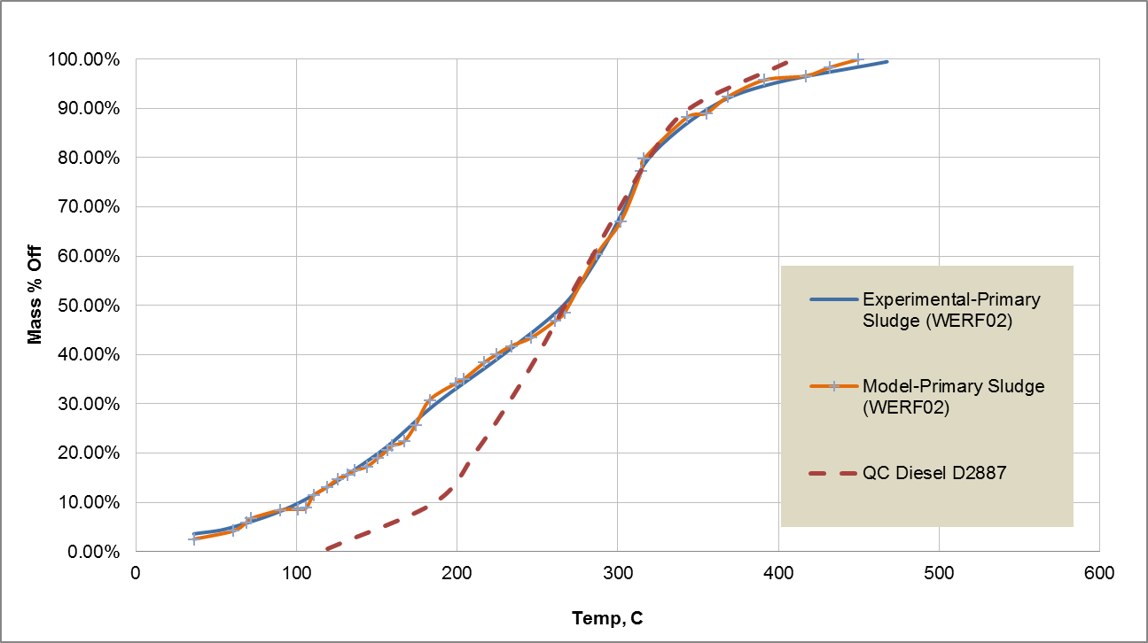

**Figure 3.** Boiling point curve (ASTM D2887) for hydrotreated sludge HTL oil.

The heavy oil from hydrotreating is assumed to be hydrocracked into additional gasoline and diesel range fuel. No experimental data are yet available for hydrocracking of HTL biocrude, so it is assumed that the heavy fraction is processed similar to petroleum operations. The hydrocracking assumptions for the model are given in Table 5.

**Table 5** Hydrocracking model assumptions.

|  |  |  |
| --- | --- | --- |
| **Process** | **Basis** | **Assumptions** |
| Hydrocracking heavier than diesel portion of hydrotreated HTL oil | No experimental data, assumed to be similar to conventional hydrocrackers  Temperature: 390 °C  Pressure: 1010 psia | H2 chemical consumption:  0.004 wt/wt heavy oil  Product breakdown:  Gas (excluding excess H2); 3 wt%  Liquid fuels: 96 wt%  Aqueous: 1 wt% |

## Process Economics and Sensitivity Analysis

The MFSP for the sludge HTL biocrude production plant and the centralized biocrude upgrading plant is determined using a discounted cash flow rate of return analysis. The summary economics and performance for the HTL plant and the upgrading plant are presented in the following sections. Sensitivity analysis around key technical and economic assumptions is also presented.

## Sludge HTL Plant

Table 6 gives the overall process economics for the base case sludge HTL plant. The plant processes 100 dry ton/day primary sludge (at $0/dry ton) and produces 3 million gal/yr (234 BPSD) of biocrude at a MFSP of $4.09/gge ($4.01/gal). The breakdown of costs that make up this price are shown in the manufacturing costs section of the table. The total capital investment for the plant is $54.1 million.

Figure 4 shows the sensitivity of biocrude MFSP to select economic and technical modeling parameters. A wide range of plant scale (20 to 950 ton/day) was chosen to include the highest sludge producing waste water treatment plants in the U.S. This range represents about 56% of the total primary and secondary sludge produced. The HTL biocrude yield sensitivity range was chosen based on that achieved in experimental testing of primary, secondary and biosolids sludge, as well as what the researchers feel is attainable with future research advancements. The ash-free dry weight (AFDW) yields attained in the laboratory are 32-40% for primary sludge, 25% for secondary sludge, and 31-35% for biosolids. It is thought that a 10% improvement in yield is achievable for the HTL of primary sludge. Therefore, a range of 25-45% is chosen for the sensitivity analysis. The sludge credit is an initial approximation of what WWTPs currently pay for sludge/biosolids disposal or land application. A brief literature review indicates that municipalities pay as much as $125/dry ton for disposal of sludge wastes (EPA 1995). A feedstock cost of $25/ton is used as a conservative bound to account for the possibility that the treated sludge (biosolids) may be sold as compost. For slurry solids content, a maximum of 15% is thought to be possible while still enabling effective pumping.

**Table 6** Base Case Summary Economics and Performance for Sludge HTL/CHG Plant



**Figure 4** Sensitivity analysis for HTL plant processing waste sludge.

Given that plant scale and the potential sludge credit value are highly variable and uncertain at this time, Figure 5 shows further detail on the effect of these parameters on the biocrude MFSP. It appears that below about 100 ton/day capacity, biocrude price is outside the range of economic feasibility, even with a sludge credit of $125/dry ton. Although scales lower than this produce expensive biocrude, scenarios feeding a variety of biocrude production capacity to a centralized plant would be likely and more economically feasible (e.g., a very large metropolitan POTW and several smaller ones in the suburbs). For example, assuming a $50/dry ton sludge credit, a scenario where an upgrading plant accepts biocrude from one 500-ton/day, four 250-ton/day, six 100-ton/day and eight 50-ton/day HTL plants results in a significantly reduced price from the base case, at $3.18/gge biocrude ($3.12/gal), as shown in Table 7. This type of combined scale scenario, along with improvements in biocrude yield and feed solids content, could bring the price down to $2.40/gge biocrude, as illustrated in Figure 6.

**Figure 5** Effect of plant scale and sludge credit on biocrude MFSP.

**Table 7** Overall feedstock biocrude price for an upgrading plant using feed from variable HTL plant sizes (including $50/dry ton sludge credit).

|  |  |  |  |  |
| --- | --- | --- | --- | --- |
| WWTP Scale (dry ton/day sludge) | # of Plants | Biocrude Price $/gal (includes $0.10/gal shipping) | Final Upgraded Fuel, BPSD | Total Biocrude Price, $/day |
| 500 | 1 | 2.17 | 1009 | 91,997 |
| 250 | 4 | 2.66 | 2019 | 225,540 |
| 100 | 6 | 3.61 | 1211 | 284,654 |
| 50 | 8 | 4.75 | 808 | 161,100 |
|  |  |  |  |  |
| Total |  | $3.12/gal ($3.18/gge) | 5047 | 662,292 |

**Figure 6** Combined reductions in MFSP with applied sludge credit, technology advancements, and combined scale scenario.

## Sludge Biocrude Upgrading Plant

Table 8 gives the summary economics for the base case upgrading plant processing biocrude feed at $4.19/gge (includes $0.10/gge transport cost). The plant produces 5,047 BPSD of naphtha and diesel fuel at a MFSP of $5.15/gge and a total capital investment of $184.6 million. Figure 7 shows the sensitivity of final fuel MFSP to several economic and technical parameters for the biocrude upgrading plant model. Biocrude feedstock price was varied widely according to the price range resulting from the HTL plant sensitivity analysis (Figure 4). The range for hydrotreating oil yield is based on that achieved in the experimental testing. A maximum upgraded oil yield of 93 g dry oil/g dry biocrude was achieved for biocrude from HTL of biosolids (90 g/g was chosen as a conservative max) and a minimum of 70 g dry oil/g dry biocrude was chosen as a conservative lower bound. Upgrading at an existing petroleum refinery is also considered where only operating costs associated with fuel upgrading are included in the economics (TCI = 0 case).

**Table 8** Base Case Summary Economics for Sludge HTL Biocrude Upgrading



**Figure 7** Sensitivity analysis for sludge HTL biocrude upgrading plant.

**Figure 8** Reduction in upgraded fuel price with combined technology improvements.

## Conclusions and Recommendations

Sludge HTL and biocrude upgrading is an attractive alternative to anaerobic digestion and other sludge management methods that has the added benefit of producing salable fuel substitute for petroleum diesel and naphtha. The base case scenario for this analysis consists of 25 100-dry ton/day sludge HTL plants feeding into a centralized upgrading plant producing 5,000 BPSD of diesel and naphtha. The base case assumptions result in a minimum fuel selling price of $4.09/gge for HTL biocrude and $5.15/gge for final upgraded fuel.

This preliminary analysis is based on initial testing of primary sludge waste HTL and upgrading and as such, it is intended to be a starting point from which advancements in the technology and refinements to the analysis may be identified. Several areas of potential improvement are apparent:

* Optimization of HTL feed solids content can improve economics through increased energy efficiency (less water to heat and pump) and decreased capital cost (smaller equipment size). A maximum 15% solids content is thought to be possible while still allowing effective pumping through the HTL system. Increasing solids level to 15% reduces the base case biocrude MFSP by $0.56/gge. Further testing is needed to validate HTL performance at this level of solids. Testing is also necessary to ensure that dewatering of sludges to 15% is possible.
* A maximum HTL biocrude yield of 45% is thought to be achievable, which alone would reduce the base case biocrude price by $0.40/gge. Further testing for optimization of biocrude yield is needed. In addition, as most wastewater treatment plants produce both primary and secondary sludge waste, testing of mixtures of these feeds will help to more realistically model the production plant.
* The base case assumes an upgraded biocrude yield of 78.6 g/g dry biocrude (based on testing of primary waste), however, yields as high as 93 g/g dry biocrude were achieved in the testing of biocrude from biosolids sample. An increase in yield to 90 g/g biocrude reduces the base case final fuel MFSP by $0.61/gge. Further testing is needed on biocrudes from primary, secondary, and biosolids wastes, and combinations thereof, to achieve optimized hydrotreated oil yields.
* The economics of the HTL plant are highly sensitive to sludge credit value (the current cost to treat and/or dispose). While the base case does not consider any cost savings associated with avoided sludge disposal, it is more likely that the current costs associated with sludge management would translate to a potential feedstock credit. If a sludge credit of $50/dry ton is considered, the upgraded fuel MFSP is reduced by $0.57/gge. A more detailed analysis of the actual savings from avoidance of sludge waste disposal is needed.
* The choice of the base case HTL plant scale is roughly based on the number and capacity of existing WWTPs in the US and what the resulting biocrude availability might be within a reasonable transportation radius. The base case assumes that the biocrude is transported by tanker truck 100 miles to the upgrading plant at a cost of $0.10/gal, however, sensitivity analysis shows that larger draw radii that allow for larger plant scale could improve economics. In addition, scenarios combining large and small scale WWTPs could significantly reduce MFSP. Further collaboration with the resource analysis team is needed to develop and model realistic scale scenarios (and combinations) that could be beneficial.

When combined improvements and refinements in all of these areas are considered, it is feasible that biocrude could be produced for as low as $2.37/gge (Fig. 6) and upgraded fuel may be produced for as low as $2.92/gge (Fig. 8). In addition, work being conducted under separate BETO projects is investigating alternative HTL aqueous phase treatment methods that may yield higher-value products compared to methane, which could further improve plant economics. Upgrading at an existing refinery could offer additional economic benefit as well.

## References

Dutta, A., Talmadge, M., Hensley, J., Worley, M., Dudgeon, D., Barton, D., Groenendijk, P., Ferrari, D., Stears, B., Searcy, E., Wright, C., Hess, J.R. (2011). Process design and economics for conversion of lignocellulosic biomass to ethanol: thermochemical pathway by indirect gasification and mixed alcohol synthesis. Golden, CO: National Renewable Energy Laboratory. <http://www.nrel.gov/docs/fy11osti/51400.pdf>

Environmental Protection Agency, Biosolids Website, 2015. <http://water.epa.gov/polwaste/wastewater/treatment/biosolids/genqa.cfm>

Environmental Protection Agency. Process Design Manual: Land Application of Sewage Sludge and Domestic Septage. EPA/625/R-95/001. September 1995.

U.S. Department of Energy. March 2015. Biomass Multi-Year Program Plan. Bionergy Technologies Office, Energy Efficiency and Renewable Energy, U.S. Department of Energy, Washington D.C.

Humbird, David, R. Davis, L. Tao, C. Kinchin, D. Hsu, A. Aden. 2011. “Process Design and Economics for Biochemical Conversion of Lignocellulosic Biomass to Ethanol Dilute-Acid Pretreatment and Enzymatic Hydrolysis of Corn Stover.” NREL/TP-5100-47764, National Renewable Energy Laboratory, Golden, CO. Accessed at <http://www.nrel.gov/docs/fy11osti/47764.pdf>

Jones, S., P. Meyer, L. Snowden-Swan, A. Padmaperuma, E. Tan, A. Dutta, J. Jacobson, and K. Cafferty. “Process Design and Economics for the Conversion of Lignocellulosic Biomass to Hydrocarbon Fuels: Fast Pyrolysis and Hydrotreating Bio-oil Pathway.” November 2013. Pacific Northwest National Laboratory, Richland, WA. PNNL-23053.

Jones, S., Y. Zhu, D. Anderson, R. Hallen, D. Elliott, A. Schmidt, K. Albrecht, T. Hart, M. Butcher, C. Drennan, L. Snowden-Swan, R. Davis and C. Kinchin. “Process Design and Economics for the Conversion of Algal Biomass to Hydrocarbons: Whole Algae Hydrothermal Liquefaction and Upgrading.” March 2014. Pacific Northwest National Laboratory, Richland, WA. PNNL-23227.

SCAP, Southern California Alliance of Publicly Owned Treatment Works (SCAP), “2012 SCAP Biosolids Trends Survey”. 2013.

## Appendix B

**Table A1. Nth-Plant Assumptions**

|  |  |
| --- | --- |
| **Assumption Description** | **Assumed Value** |
| Internal rate of return | 10% |
| Plant financing debt/equity | 60% / 40% of total capital investment |
| Plant life | 30 years |
| Income tax rate | 35% |
| Interest rate for debt financing | 8.0% annually |
| Term for debt financing | 10 years |
| Working capital cost | 5.0% of fixed capital investment (excluding land) |
| Depreciation schedule | 7-years MACRS schedule |
| Construction period | 3 years (8% 1st yr, 60% 2nd yr, 32% 3rd yr) |
| Plant salvage value | No value |
| Start-up time | 6 months |
| Revenue and costs during start-up | Revenue = 50% of normal  Variable costs = 75% of normal  Fixed costs = 100% of normal |
| On-stream factor | 90% (7,884 operating hours per year) |